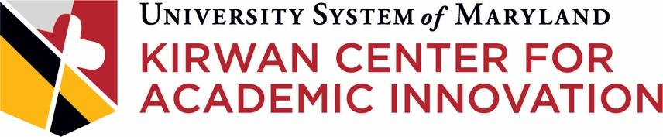

Types of Studies that Fall Under the USM SoTL Umbrella Protocol

INTRODUCTION
In Fall 2021, the Kirwan Center for Academic Innovation partnered with the Human Research Protection Program in the UMCP Division of Research to develop a Systemwide IRB protocol for USM faculty engaging in Scholarship of Teaching and Learning (SoTL) research projects that pose minimal risk to participants. The Kirwan Center oversees the standing SoTL IRB protocol that has been approved by UMCP’s Institutional Review Board.

We define SoTL as the systematic investigation of student learning, instruction, and/or teaching innovations and the dissemination of findings so as to contribute to a broader knowledge community. SoTL projects at their essence aim to improve student success by providing an evidence base to help inform course design and instructional decisions undertaken by faculty and programs.

Once a reliance agreement is in place between UMCP and another USM institution, faculty from that institution can propose specific SoTL projects that pose minimal risk to participants using a streamlined amendment form that will go to the UMCP IRB for expedited review.

TYPES OF STUDIES THAT FALL UNDER THE PROTOCOL
Instructors and programs at USM institutions that are pursuing educational interventions need to understand the impact of those interventions, whether on the faculty who engage in them, the staff who support them, or the students who experience them. There are a variety of ways to study the impacts of education interventions, such as:

Studies Involving Students and/or Student Record Data
These kinds of studies may involve researchers seeking to understand the impact of interventions, such as a new pedagogical technique, on the knowledge, attitudes, behaviors, or skills of students, or on their grades or performance on other assessments. These kinds of studies may also involve researchers seeking to understand the perceptions or lived experiences of students regarding the classroom environments, course designs, pedagogies, or co-curricular activities they experience or the introduction of teaching and learning innovations into their educational experiences. These kinds of studies may also include the researchers seeking to understand the impact that factors outside the teaching and learning experience, such as institutional policy or outside responsibilities of students, have on students vis-a-vis the teaching and learning experience.

These kinds of studies may involve researchers collecting and analyzing data that stems from assigned activities that all students must complete as part of a course or program (e.g., concept inventories, assignments, papers, projects, quizzes, or exams). These kinds of studies may involve researchers collecting and analyzing data that does not stem from assigned activities that all students complete as part of a course or program (e.g., a survey instrument related to student self-efficacy in mathematics). These kinds of studies might also include the use of data that exists outside of a course, such as demographic data, grades in previous courses, etc.

NOTE: Studies that include students should be sure to consider FERPA stipulations with respect to the gathering or use of student information, as well as parental consent or waiver of parental consent if any study participants are under age 18.

Studies Involving Faculty and/or Staff
These kinds of studies may involve researchers seeking to understand the impact of interventions, such as participation in professional development opportunities, on the knowledge, attitudes, behaviors, or skills of faculty and/or staff. These kinds of studies may also involve researchers seeking to understand the perceptions or lived experiences of faculty members or staff regarding their classroom environments, course designs, or pedagogies or the introduction of teaching and learning innovations into their practice. These kinds of studies may also include researchers seeking to understand the impact that factors outside the immediate teaching and learning experience, such as institutional policy or non-teaching responsibilities of faculty and/or staff, have on faculty and/or staff vis-a-vis the teaching and learning experience.

NEXT STEPS
If you’re a faculty member at an institution that has a reliance agreement in place with UMCP, your next step is to complete and submit the amendment form and associated documentation (up-to-date CITI Training record for each study team member, plus all relevant supporting documents including: consent forms, information sheets, recruitment materials (letters, telephone scripts, advertisements, etc.), instrumentation (surveys/questionnaires, interview protocols, etc.), and any other material that will be presented to, viewed by, or read to human subject participants). Once an amendment form is completed and associated documentation compiled, the faculty member should submit their amendment package to sotlresearch@umd.edu.

FOR MORE INFORMATION
For an overview of the project, visit the Kirwan Center’s IRB for SoTL webpage.

USM Faculty interested in proposing a study under the umbrella protocol should consult the “Systemwide IRB - Scholarship of Teaching & Learning (SoTL) Resources” on the UMCP Investigator Support and Resources page.

Questions may be directed to Nancy O’Neill, Acting Director, USM Kirwan Center for Academic Innovation, at cai@usmd.edu.

